<ENTER YOUR Project NAME>
Project Abstract
Version 1.0

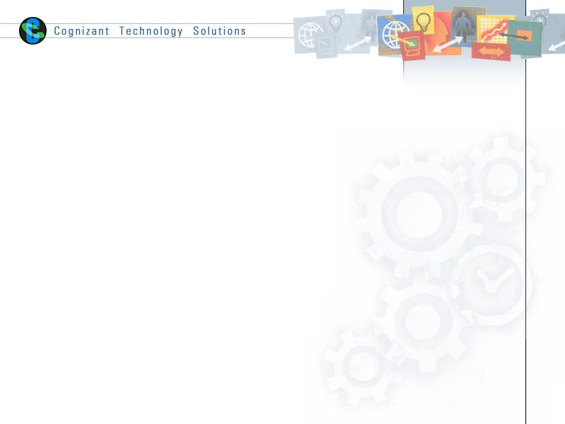

 | - Prepared By / Last Updated By | - Reviewed by | - Approved By
- Name | <Project Member to fill> | <Trainer/Project Governance Representative/Cohort Mentor to fill> | <Trainer/Project Governance Representative/Cohort Mentor to fill>
                - Role
                - Signature
                - Date

Table of Contents
1.0 Purpose of this document 4
2.0 Business Case 4
3.0 Appendices 4
3.1 Glossary 4
3.2 Other 4
4.0 Terms & Conditions 5
5.0 Change Log 5

Purpose of this document
This document provides an overview about the business need and the solution that can be provided to fulfil the objective.

Business Case
<Project Member to fill>

Appendices

Glossary
Acronyms | Definitions

Other

Terms & Conditions
Disclaimer: Please do not circulate or distribute this document outside of Cognizant Network, We have a Zero Tolerance Policy. Kindly adhere to 100% Compliance at all times.

Change Log
Please note that this table needs to be maintained even if a Configuration Management tool is used.
- Version Number | - Changes made
V<n.n> | <If the change details are not explicitly documented in the table below, reference should be provided here>
 | Page no | Changed by | Effective date | Changes effected

